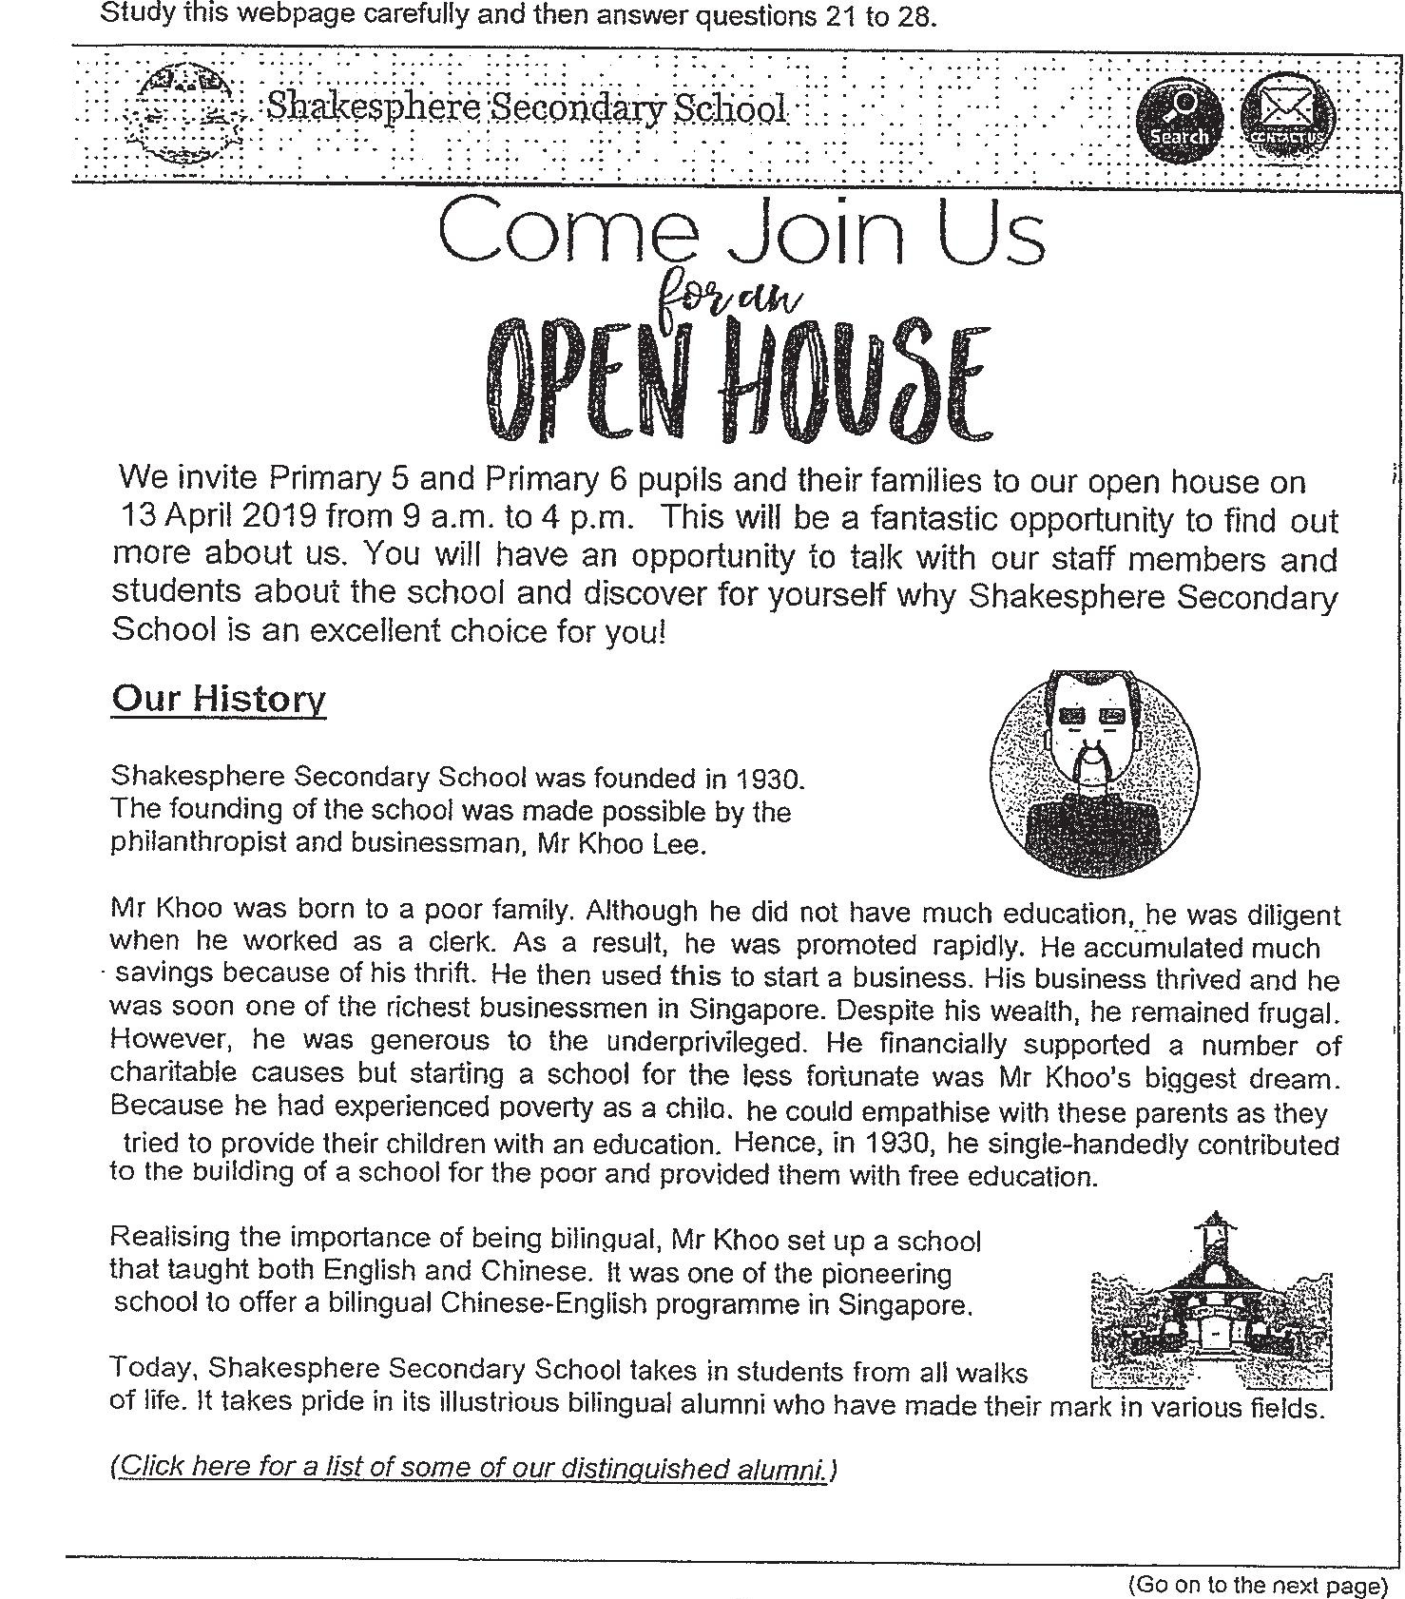

faisnalistory

(Click here for a list of some of our distingtpy alumni}